Animoto instructions
Create a slide show using photographs and music
- Collect a series of 8–15 images that you wish to present in a 30 second slide show.

- Choose and save an MP3 music file to accompany your images from the Creative Commons site Jamendo to your folder. You may also use music or images provided by Animoto.

- Go to Animoto <http://animoto.com/create>.

- Sign up to register for Animoto. Your email will not show in public.

- To find your completed video, look in My videos. Send the URL of your completed video to your teacher so they can click to see it without joining Animoto.

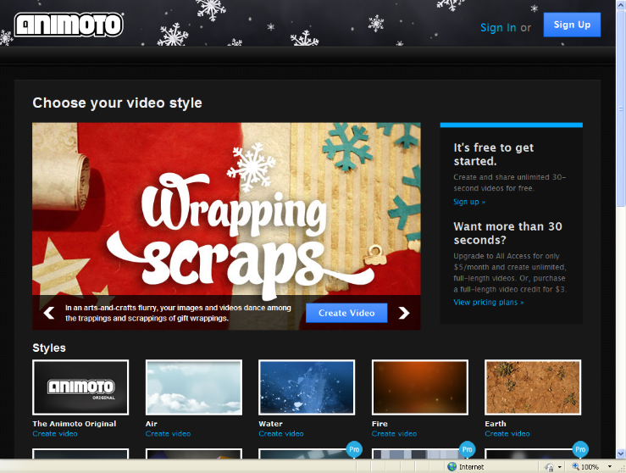
- Styles: Choose The Animoto original and click on Create video.
- Choose make a 30-second video for free. You will now need to Sign in.
- Upload pictures from the folder on your computer or select images from the collection.
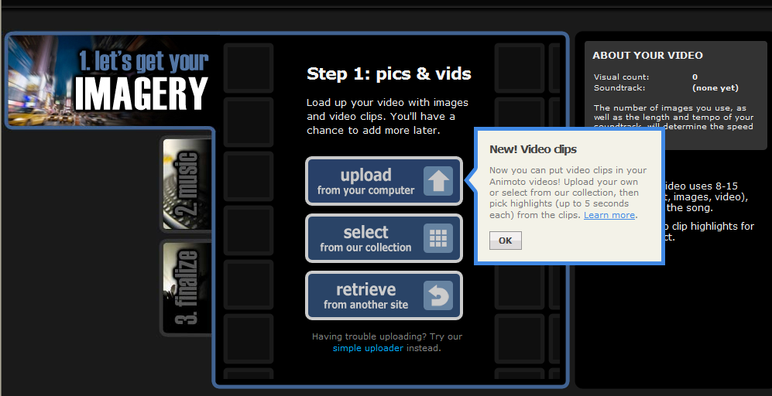
- In your folder, highlight all the selected pictures and click the open command – this will import all the pictures at once.
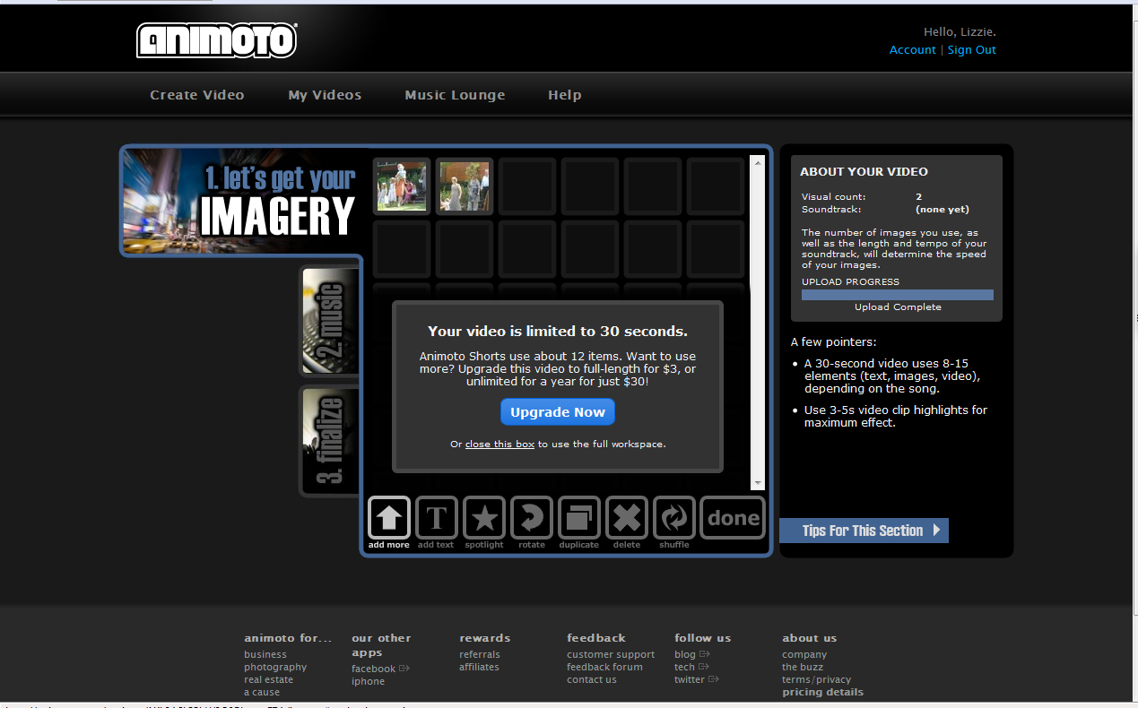

Add more pictures; Spotlight favourite images; Close; Click done
Choose upload from your computer to import your MP3 music file from your folder. Save and continue.
- Finalize your video: Choose the continue option. Write a title and description and Animoto will create your video in the next 15 minutes. Your video is now ready to share!

