POWERPOINT TIPS & TRICKS
Removing the background from an image

- Insert the image into PowerPoint.

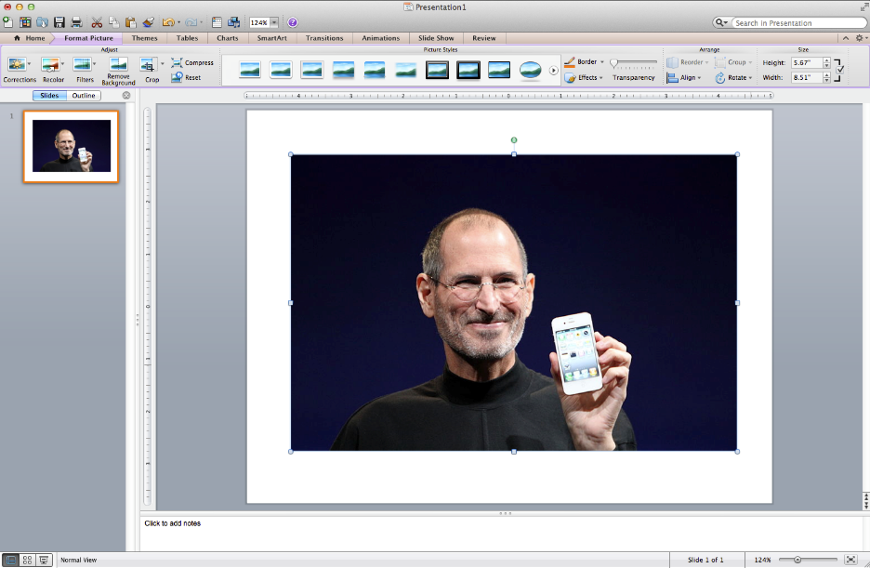

- Under the 'Adjust' toolbar, choose 'Remove Background.'
- It will automatically try to remove the background but may not be perfect.
- Click on areas to add or remove it from the final cropped image.
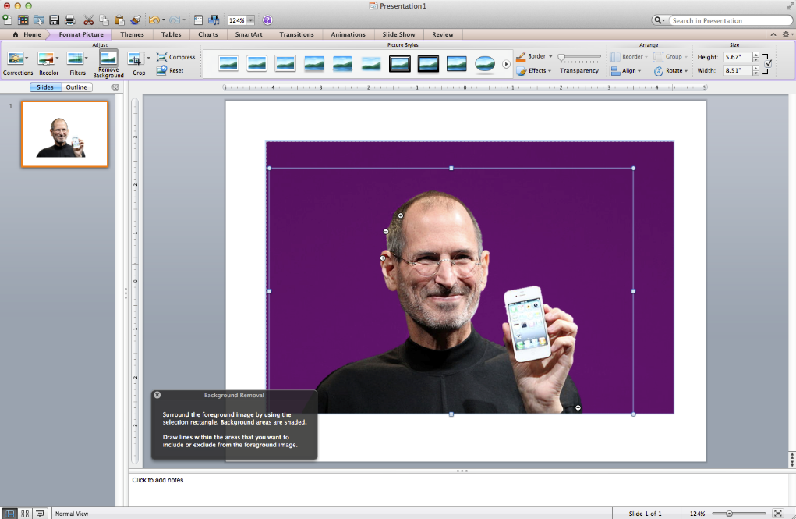
Areas highlighted in purple will be removed. Drag the corners of the box to include them or click on them to add a plus-sign OR the minus-sign to remove them.

5) Click out of the image when you are finished and you now have a clean, sharp image.

