POWERPOINT TIPS & TRICKS

Inserting a video
- Locate and save a video into the same folder as your Powerpoint Presentation
- Your video file should be .wmv
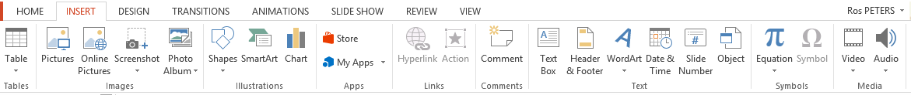
- On the INSERT menu bar choose Videos on my PC
- Locate your video
- When you return to Powerpoint you will be asked if you wish to play automatically when you get to that slide in your presentation OR play when you click on your mouse in the movie window. Choose your option.
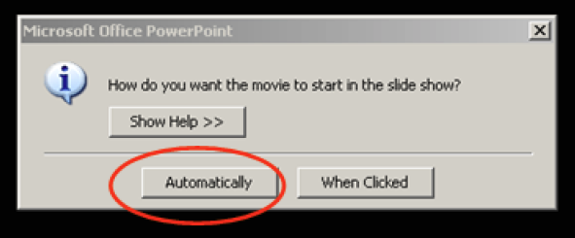

- Test your video and click the PLAY button to view.

Trim a video
Sometimes you do not need to use the entire video in your presentation. Fortunately, you can fix this problem with the Trim Video feature by trimming the beginning and end of your video clip.
1.Select the video on the slide.
2.Under Video Tools, on the Playback tab, in the Editing group, click Trim Video.
3.In the Trim Video dialog box, do one or more of the following:
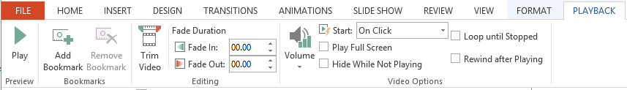
  - To trim the beginning of the clip, click the start point (shown in the image below as a green marker, on the far left). When you see the two-headed arrow, drag the arrow to the desired starting position for the video.
  - To trim the end of the clip, click the end point (shown in the image below as a red marker, on the right). When you see the two-headed arrow, drag the arrow to t he desired ending position for the video.

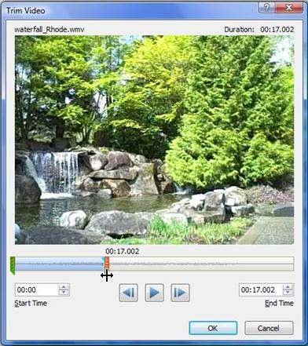

4.TIP: You can do the same steps for audio clips!

POWERPOINT TIPS & TRICKS

LASER POINTER
The laser pointer allows you to identify which parts of the slide you wish your audience to view.
Start your presentation.
Press and hold CTRL, click the left mouse button, and point to the contents on the slide that you want to draw attention to
To change the color of the laser pointer, do the following:
  - On the Slide Show tab, in the Set Up group, click Set Up Slide Show.
  - In the Set Up Show dialog box, under Show Options, select the color that you want from the Laser pointer color list, and then click OK.
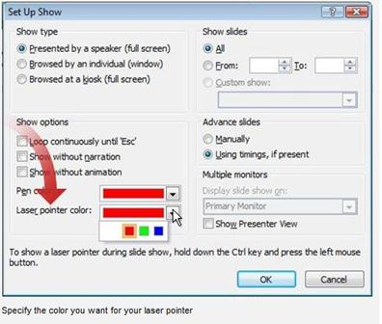

AUDIO TOOLS
You may wish to insert sound into your presentation. You can choose to have music playing across the entire presentation OR insert an individual audio file OR narrate your presentation.
Click the Insert tab located along the toolbar and choose the Audio icon
You have options for Audio from File, Clip Art Audio, and Record Audio.
If you choose the Audio from File option you will need to locate a saved audio file and click OK
Now click the speaker button beside the audio file you have inserted, and the Audio Tools toolbar is displayed. Click the Playback icon.
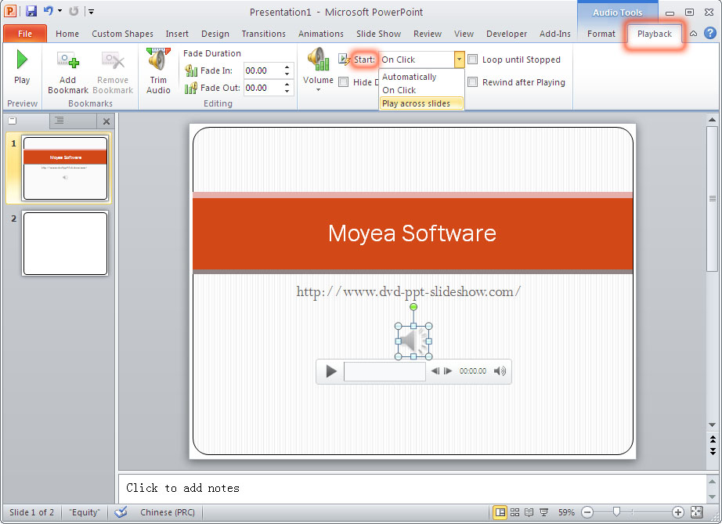
Select the Play across slides option from the toolbar.
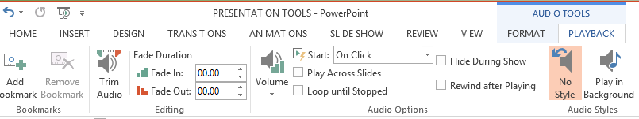
You may wish to choose Play in the Background option for music.
You can also control Fading in and Out of sound; when to stop the audio; and you can hide the speaker button.
ADDING NARRATION
You can add your own voice to your presentation and enable it to be played independently.
First go to the Slide Show menu item on the toolbar.
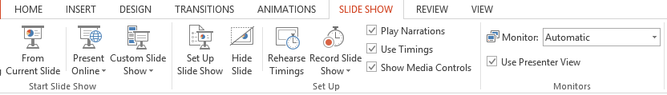
Choose the Record Slide Show button and the select whether you want to a) Start recording from the beginning, or b) Start recording from the current slide.
A small recording button appears on the top-left of your screen
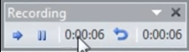
Record your voice over each slide moving them forward as you go
You can pause your recording at any point and then resume
To END the recording simply press the ESC key
Look at your presentation in the SLIDE SORTER view
Each slide with sound will have a speaker icon and a time allocation

