Prezi instructions

- Organise your ideas for a presentation using a mind map. Your ideas should be in a logical sequence.

- Go to Prezi at http://prezi.com and Sign up to register.

- Log in and begin creating. You can create a prezi over a number of sessions, as long as you save your work. You will work within Your prezis.

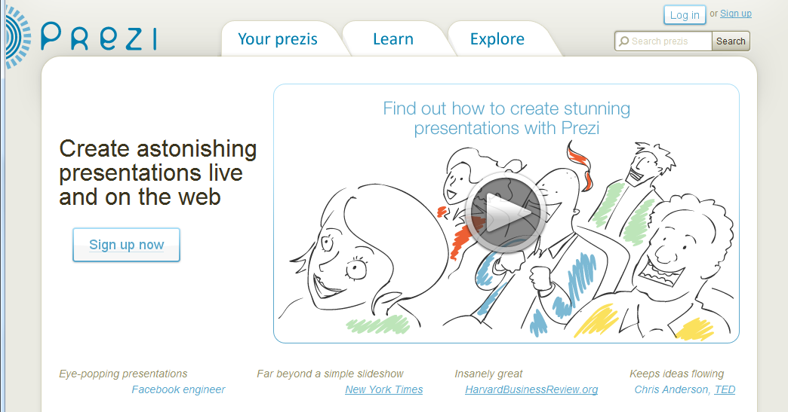

- New prezi: Your prezis – New prezi – Title - Description

- The dashboard: Double click anywhere on the canvas and a text box appears to write in. Big ideas are expressed in large font, linked examples are in smaller font. Group your examples with their big idea using a Frame each time.
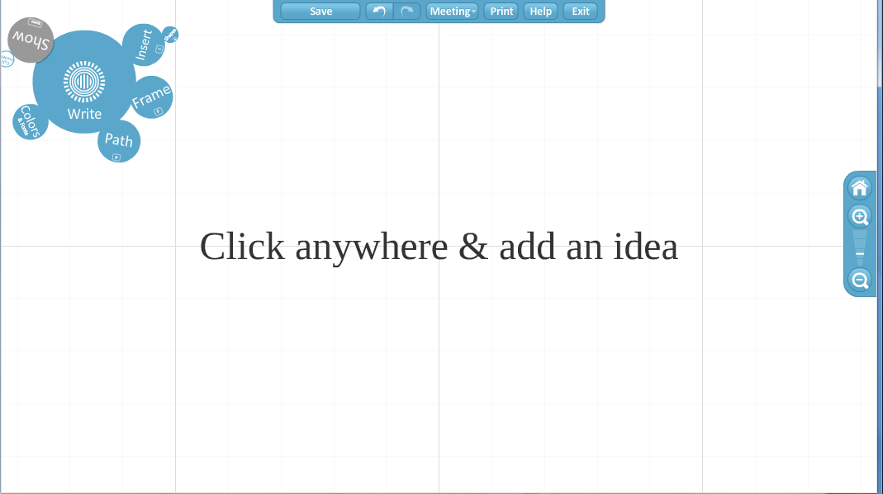
- Help: Orientation to Prezi. The Getting started video is very clear.
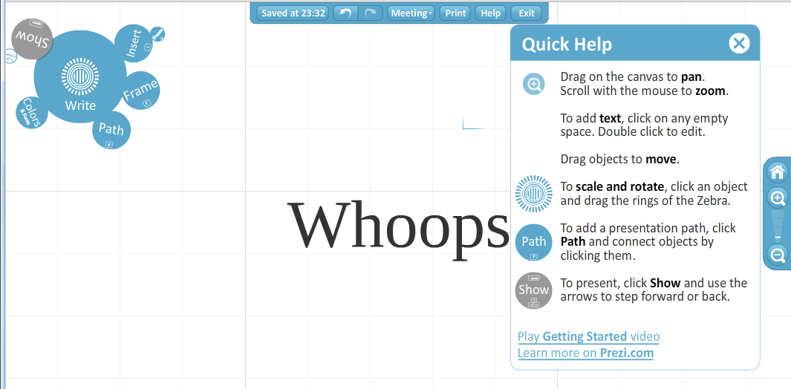

- Edit: Click on selected object/word: Zebra - Move – Resize - Rotate
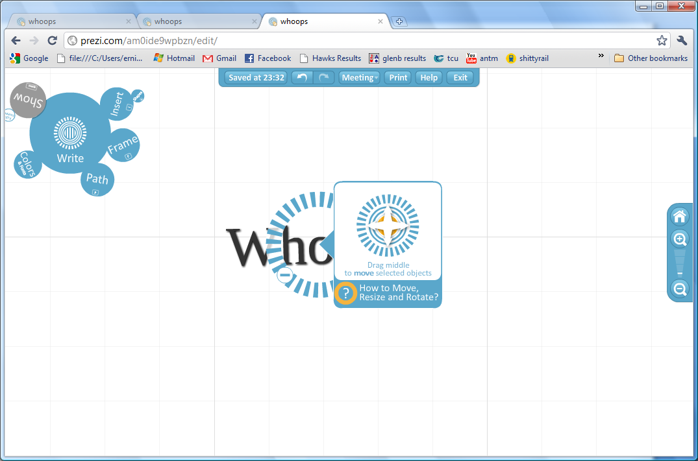
Insert images – Upload from computer

- You can insert images and click on canvas to write in text boxes. Choose Colors and fonts. Zoom out and in [- and + icons].
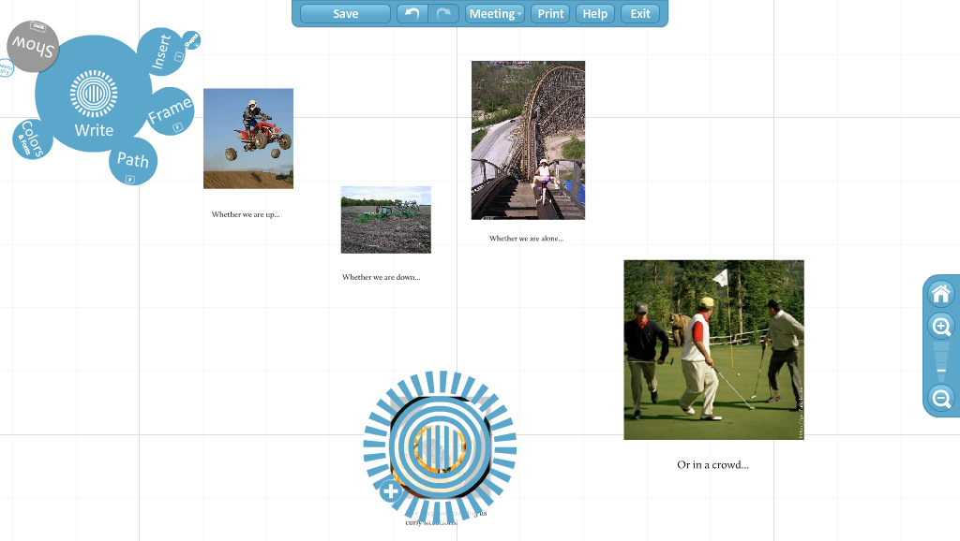
The editing zebra appears when you click on an object to edit it.
- Group ideas: Click on Frame to group linked ideas together
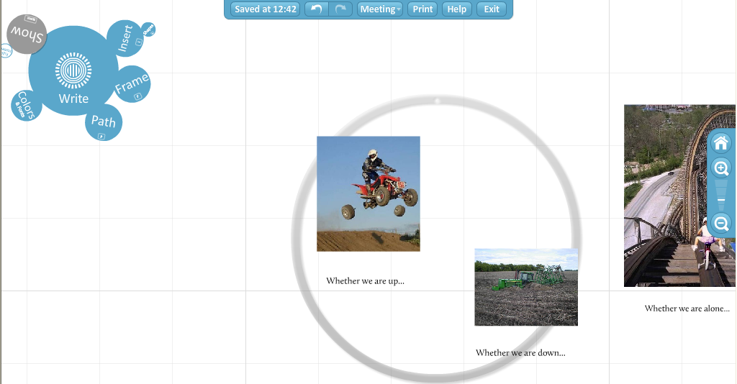

- Choose your reading path: Click on Path and then on each image in sequence to create a reading pathway through the presentation. Save and Exit.
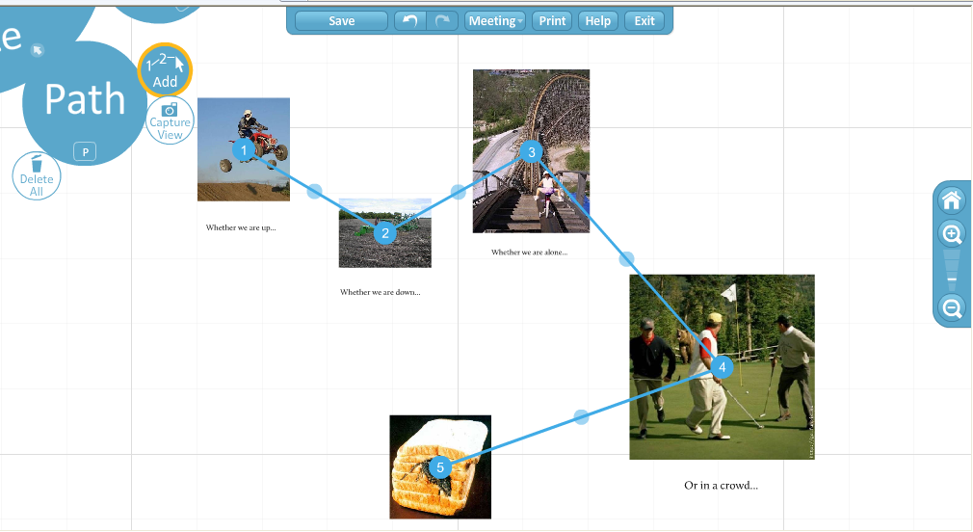

- Managing your prezi file. Click on the image of your prezi to open it. Edit prezi, Save a copy, Delete or Download your prezi. NB As you save, your prezi is automatically being published.
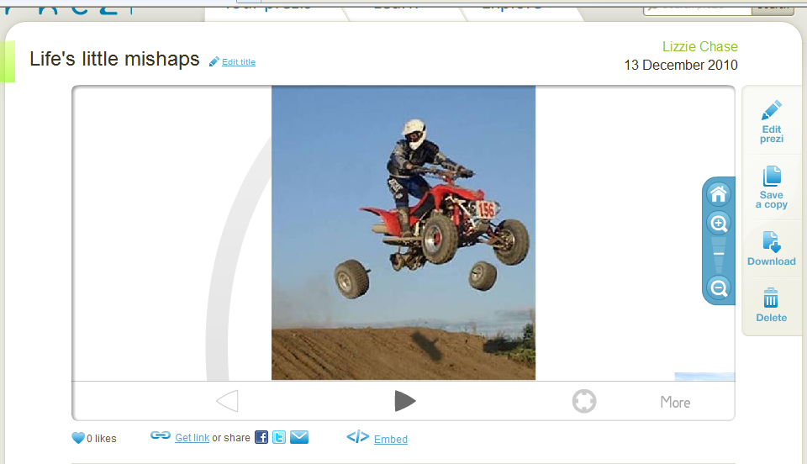
- Share your prezi: Get link and share your prezi. The default mode for presentations is Public and allow copy.

